**Report of A Simple SDN Controller Design using Trema**

Ahmed Al Obaidi, Bhagyeshree Gaikwad and Varun Parkhe

* **Introduction**

In this project, we used Trema, which is a full-stack, easy-to-use framework for developing OpenFlow controllers in Ruby and C, to build Software-defined networking controller. We used customized virtual machine to run Trema. The project consists of packet-in.rb (the Trema Controller), packet_in.conf (the configuration file for the Controller which has the switch and the hosts) and fdb.rb (the forwarding database). All these files are stored in trema-edge/src/examples/packet_in/.

* **Running the Project**

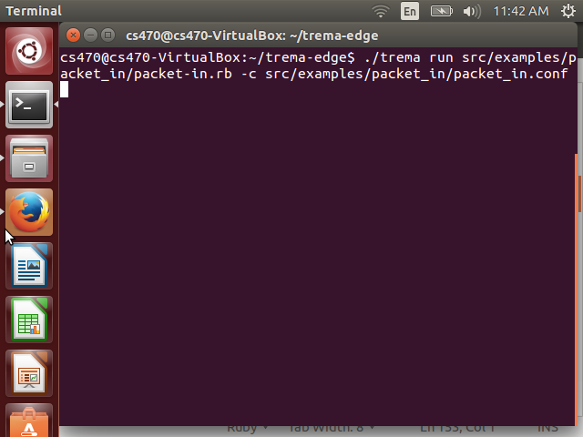 First of all, we have to move to trema-edge folder, and we do that by typing (cd trema-edge) after we open the terminal in the virtual machine. Then we type the following to run trema and its controller (./trema run src/examples/packet_in/packet-in.rb src/examples/packet_in/packet_in.conf). The controller will be waiting for packets to be sent from and to any of host1, host2 and host3.

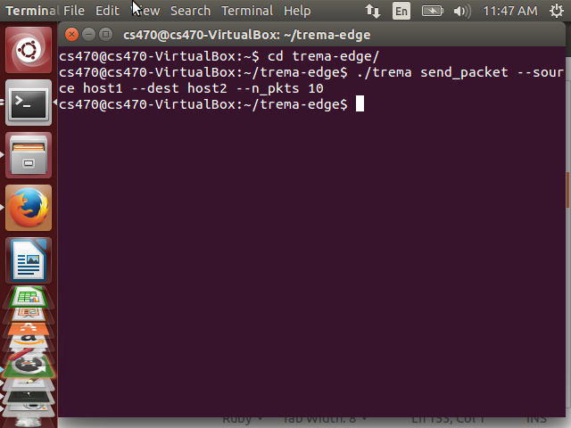We open a new terminal and we send 10 packets from host1 to host2 by typing (./trema send_packets --source host1 --dest host2 --n_pkts 10) .

When we open the first terminal we can see the 10 packets information which we sent from host1 to host2.

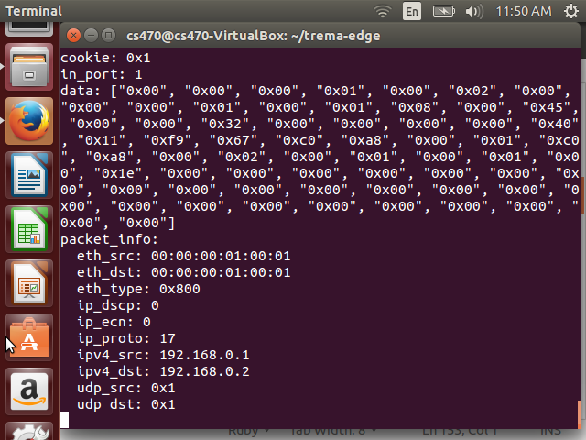Let us check if that is true by opening a new terminal and typing (./trema show_stats host1) to check host1 and (./trema show_stats host2) to check host2. In the following picture, it shows that host1 sent 10 packets to host2, and host2 received 10 packets from host 1.

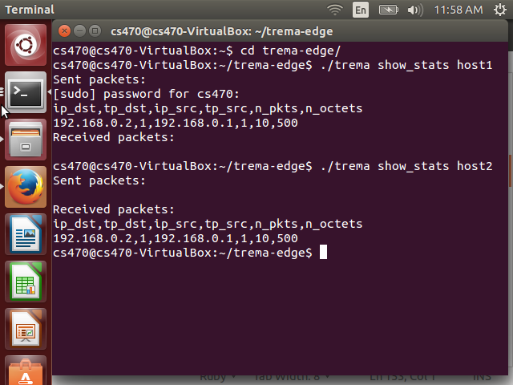

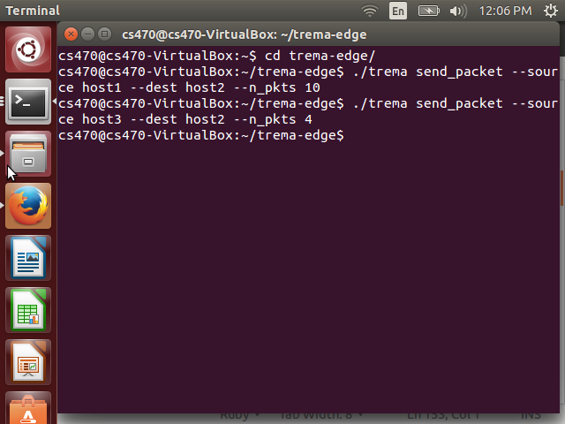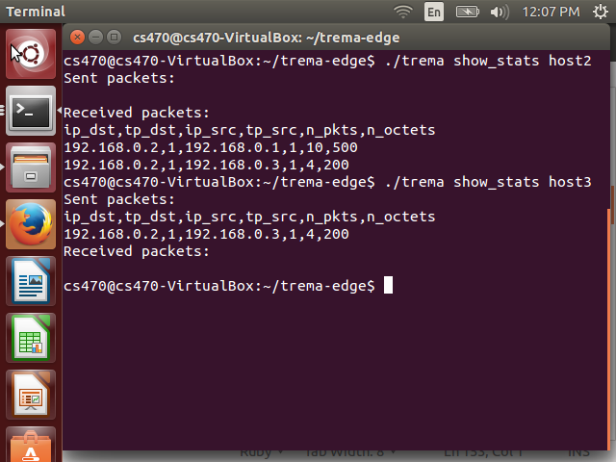Now, let us send 4 packets from host3 to host2, and then we check if host3 sent the packets to host2. That is shown in the following pictures.

When we check the stats of host2, we can see that it received 10 packets from host1 and 4 packets from host3, but when we check the status of host3, we see that it sent 4 packets to host2.

To sum up, the major part of this project is to allow the switch to forward the packets to the hosts in that network by using the controller to do that.